**Flow of the Presentation**

* Executive Summary (Talk about the 3 Questions asked and answers in brief)
* Data Exploration – Talk about pie chart of BHC and show Trend chart
* Model Equation – Copy from paper
* Model build – Initial Model (regression 1a) -> add control Variables –> Interaction Variables -> Fixed Effects
* Propensity Matching model -
* Robustness Tests –
* Final Recommendations - Shenay add this part
* Appendix – Final Results & Codes

1. **Did the banks decrease their trading assets after the announcement of the new regulation?**

Yes, there was an effect on the Trading asset ratios for BHCs due to the new regulations namely the Volcker rule – this finding was derived through the following analysis:

On a peripheral view the Volcker rule seem to have had no significant effect on trading assets ratios – this was drawn due to the fact that Model 1a had a small positive coefficient (the sign was not as expected as it signifies that Volcker rule had no change in trading assets).

However after including control factors we see that there is a more realistic result.(Model 1b indicates the negative coefficient), indicating that banks did reduce their trading assets after the introduction of the new regulation.

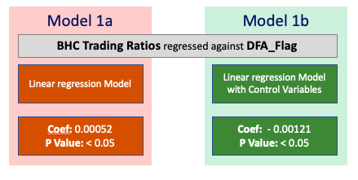

Sample you need to change

1. **If they responded to the regulation, which banks responded most and which banks least?**

**Why?**

Since we know that the Volcker rule has had some effect on the trading assets of BHCs - we decided to further understand why this effect was not as pronounced as expected (interms of magnitude of coefficient in Model 1b) and who it affected the most.

Most BHCs had 0 or insignificant trading asset ratio however there were few companies that had significant trading asset ratios.

Insert Pie chart

With this understanding a few features were engineered

* Affect - Pre-DFA average Trading ratios
* Interaction Variable between DFA_Flag and Affect

Model 2a – the Interaction Variable created showed a negative significant coefficient in the Linear model that was built with control Variables considered, Model 2b further improves our understanding of the importance of the interaction variable with the addition of the Fixed Effects. This proved that banks were affected by DFA regulations.

Since we know that most companies had negligible Trading asset ratios, we tried to categories the BHCs into those who would be affected by the Volcker rule and others – A 3% cap on pre DFA trading asset ratios seemed to have been a good cut off for this.

In summation most banks had low trading ratios and hence didn’t have a significant reaction to Volcker rule but those that had their business geared towards trading and others now banned by the Volcker rule did have a decrease in trading asset ratios (these BHCs were defined as those with Pre-DFA Trading Asset Ratios > 3%)

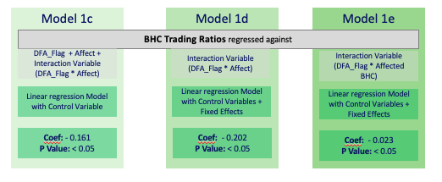

Sample you need to change

1. **Remember robustness, and how should banks or regulators use these results?**

To ensure that our results are in-fact inline we build robust models that considered control Variables and Fixed Affects into all of our models – However we did run further robustness checks

* Run a DiD model that considered only those BHCs that had Pre-DFA Trading ratios >=3% as the Treatment group – the coefficients of this model were still negative and significant
* Used Propensity matching for the treatment and Control group in the above model based on Q1 control variables so DiD is calculated using similar BHCs in control and treatment groups – which resulted in a coefficient that was still negative and similar to above

The above 2 results tested for the true affectedness of the Volcker rule based on Trading Asset Ratios however this can be disagreed by considering that banks may have all anyway considered a change in business models after the financial crisis, this was argued with the below tests:

* Consider Pre 2007 ratios before the financial crisis – this showed similar results when compared to our model results
* Removed all BHCs with 0 trading asset ratios - our results still held true

With the above tests we feel that we have a strong robust result – that Volcker rule did negatively affect Trading Asset Ratios